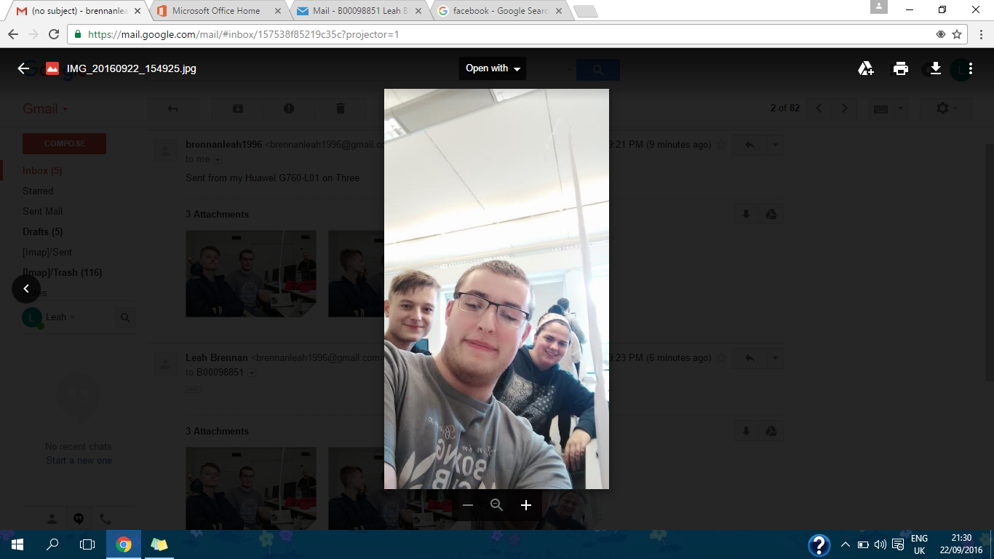

Group Name: MR BLTCB (bacon lettuce tomato Cuban barbeque)

Team Members: Tim McCann Leah Brennan Raigridas Bartkus

Final Height: 99cm